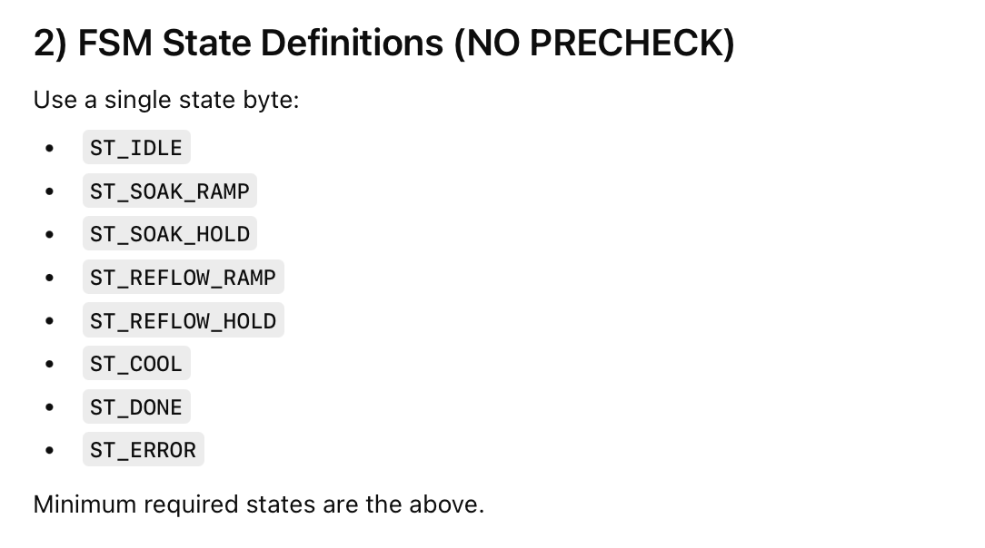
Timer Module
Responsibility: provide a stable 1-second heartbeat.
Provides: SEC_FLAG set once per second in ISR

Input Module (Start/Stop only)
Responsibility: debounce + edge detect; produce latch events.
Provides:
sets START_EVENT on a clean press
sets STOP_EVENT on a clean press (priority)

Params Module (read-only)
Responsibility: read parameters set by keypad code

Temperature Module
Responsibility: update T_CUR_C periodically.

Heater Control Module (SSR)
Responsibility: drive SSR based on FSM request.
UART Module (strip chart)
Responsibility: send temperature to PC at 1 Hz.

LCD Module (state display)
Responsibility: show state name + temperature + remaining time.

Speaker module
Responsibility: sent data to speaker emergency code

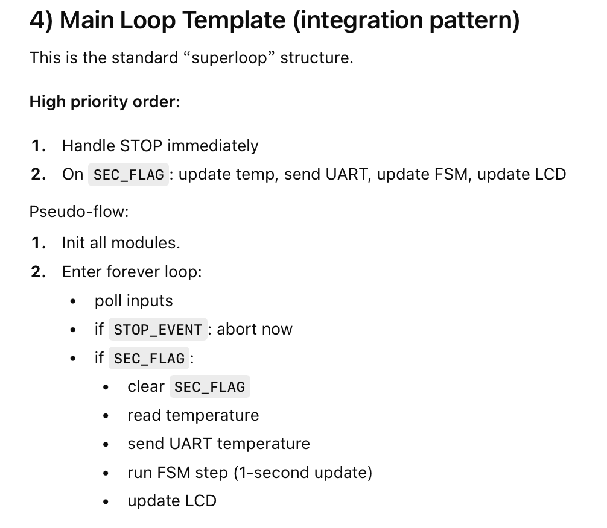
FSM Module

